Research Report on:- OTP Bypass and CAPTCHA Bypass

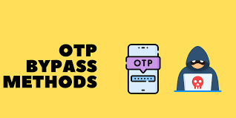

1. Introduction to OTP and CAPTCHA
OTP (One-Time Password) and CAPTCHA (Completely Automated Public Turing test to tell Computers and Humans Apart) are widely used mechanisms for verifying users and enhancing the security of online systems. Both are designed to prevent unauthorized access and mitigate fraudulent activities in digital services.
- OTP (One-Time Password): A temporary, single-use code sent to a user's mobile or email to authenticate transactions or login attempts.
- CAPTCHA: A security test that distinguishes between human users and automated bots by presenting tasks that are difficult for bots to complete, such as identifying distorted text or images.

2. OTP Bypass Methodology
OTP is widely used for securing accounts, especially in two-factor authentication (2FA). However, attackers have developed methods to bypass OTP mechanisms. Common OTP bypass techniques include:
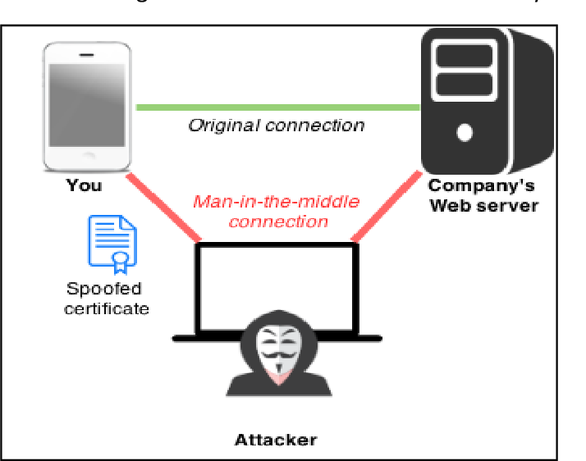
- SIM Swap Attack: An attacker tricks the victim’s mobile carrier into transferring the victim’s phone number to a new SIM card. This allows the attacker to receive OTPs sent via SMS.
- Phishing: Attackers create fake websites or apps to capture OTPs entered by users, often after tricking them into believing they are logging into a legitimate service.
- Man-in-the-Middle (MITM) Attack: In this attack, the attacker intercepts OTPs transmitted over insecure communication channels.
- Brute Force Attacks: If OTPs are not securely implemented (e.g., if there is a weak range of possible OTPs or inadequate rate-limiting), attackers may try brute-forcing through multiple OTP attempts.
Impact of OTP Bypass:
- Account Compromise: Unauthorized users gain access to sensitive accounts or data.
- Financial Losses: Bypassing OTP could lead to financial fraud or unauthorized transactions.
- Reputation Damage: Businesses that fail to secure OTP mechanisms may lose user trust.

CAPTCHA Bypass Methodology
CAPTCHA systems are designed to prevent automated bots from abusing web services. However, attackers have devised several methods to bypass CAPTCHA protections:
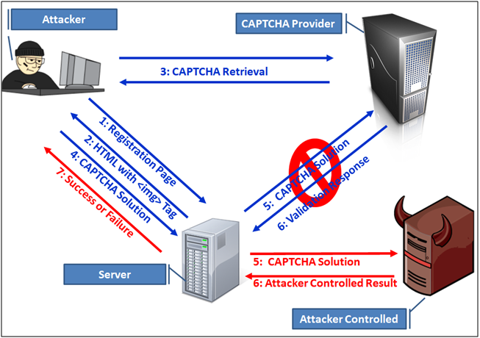
- OCR (Optical Character Recognition): By using machine learning and OCR algorithms, attackers can train bots to read and interpret CAPTCHA challenges, especially those involving distorted characters or images.
- Automated CAPTCHA Solvers: Attackers use services or scripts that employ human workers or AI to solve CAPTCHAs in real time.
- Browser Automation (e.g., Selenium): Bots can mimic human interaction with CAPTCHA elements, such as clicking checkboxes or selecting images, making it difficult to distinguish them from legitimate users.
- ReCAPTCHA Bypass: Some advanced bots can bypass Google's reCAPTCHA, particularly reCAPTCHA v2 and earlier versions, by simulating legitimate user behavior or exploiting vulnerabilities in the CAPTCHA system itself.
Impact of CAPTCHA Bypass:
- Bot-Driven Attacks: Attackers can use bots to carry out large-scale attacks like credential stuffing, account takeovers, or scraping sensitive data.
- Service Disruption: Automated bots can overload web servers, leading to service outages or degraded performance.
- Fraudulent Transactions: CAPTCHA bypass could facilitate automated fraud, leading to financial or data breaches.

4. Mitigation Measures for OTP and CAPTCHA Bypass
Both OTP and CAPTCHA systems have vulnerabilities that can be exploited. To reduce the risk of bypass, businesses and developers should implement several best practices:
Mitigation for OTP Bypass:
- Multi-Factor Authentication (MFA): Implement multi-layered authentication methods, such as combining OTP with biometrics or hardware tokens.
- Secure OTP Transmission: Ensure OTPs are sent via secure communication channels (e.g., encrypted SMS or email).
- Rate Limiting: Set limits on OTP request attempts to prevent brute-force attacks.
- SIM Locking/Carrier Protection: Users should enable SIM locking features and work with carriers to prevent SIM swaps.
- Token Expiration: Ensure OTPs have a short expiration time and are valid for one-time use only.
Mitigation for CAPTCHA Bypass:
- Adaptive CAPTCHA: Use adaptive CAPTCHA that adjusts its difficulty based on the behavior of the user (e.g., increasing difficulty for suspected bots).
- Honeypot Fields: Implement hidden fields in forms that bots might interact with, while humans do not.
- Rate Limiting & User Behavior Analysis: Monitor user behavior and detect anomalies such as multiple login attempts from the same IP in a short time.
- Invisible reCAPTCHA: Use Google’s invisible reCAPTCHA, which reduces user friction while still providing a secure mechanism.
- AI-based CAPTCHA: Implement newer CAPTCHA systems that incorporate AI challenges, making it more difficult for bots to bypass.

5. Conclusion
Both OTP and CAPTCHA are essential security measures to prevent unauthorized access and automated abuse of web services. However, these mechanisms are not foolproof. By understanding the bypass methods and implementing appropriate mitigation strategies, businesses can improve their defenses against these common attack vectors.

References
- OWASP Cheat Sheet Series - OTP (One-Time Passwords) – https://cheatsheetseries.owasp.org/
- OWASP Automated Threats to Web Applications – https://owasp.org/www-project-top-ten/
- Google reCAPTCHA v3: Invisible Security, Human Verification – https://developers.google.com/recaptcha
- MITM and Man-in-the-Middle Attacks – https://www.cio.com/article/294026/cybersecurity-understanding-the-dangers-of-man-in-the-middle-attacks.html
- Understanding CAPTCHA: The Web's Security Protocol – https://www.techradar.com/news/what-is-captcha

